Building the Workspace
Go to the directory “workspace” and execute the command:
mvn clean install -DskipTests -DskipThemes -DskipJangarooApp
The build will start to download all necessary dependencies from the CoreMedia Maven Repository. This might take 20-40 minutes, depending on the network capacities, when you do it the first time. After some minutes, you should get a BUILD SUCCESS message:
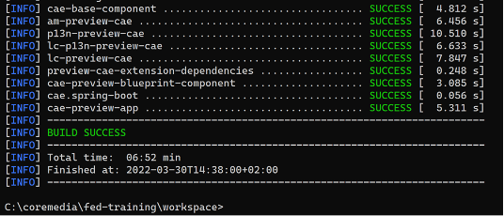
If the build fails, check your maven configuration. You have to copy the settings* files from the download to your local .m2 directory if you don't have already access to the CoreMedia repository.

